*Florida International University*

*School of Computing and Information Sciences*

CIS 4911 - Senior Capstone Project

Software Engineering Focus

Feature Document

User Story #958

**Team Member:**

Michael Martinez

**Product Owner(s)**:

Mohsen Taheri

**Mentor(s)**:

Mohsen Taheri

**Instructor**: Masoud Sadjadi

**User Story** Testing and modifying faculty project proposal process

**Description**

As a VIP user, I would like for the links of the website to work well, so that I can access them when I need to.

### **Acceptance Criteria:**

1. I would like for a PI, CO-PI coordinator, faculty login to the system, instead of “apply” under prospective students, they see “Review Student Applications”.
2. I would like for Faculty>Propose Project to have Propose Project” for (Faculty) and “Review Project Proposals” for (PI, CO-PI-COordinator)
3. I would like for Faculty>Review Application to not show for students.

**Use Case**

1. **Student, Faculty/Staff, PI/CO-PI have permissions to different types of links on header.**   
   Participating Actors: Student, Faculty/Staff, PI/CO-PI  
     
   Entry Condition: Mouse hovers over the header and links appear depending on user type.  
     
   Events Flow:
2. Students checks the header and does not see Review Application.
3. Faculty checks the header and sees the link “Propose Project”.
4. PI/CO-PI checks the header and sees the link “Review Project Proposals”.
5. PI/CO-PI and Faculty checks the header and sees “Review Student Applications”.

**Use Case Diagram**

N/A

**Sequence Diagram**

N/A

**Class Diagram**

N/A

**Unit Test & Integration Test**

* **Test Case 1**
  + **Purpose:** Test the student cannot see the Review Applications link
  + **Precondition:** Must be a student usertype in database.
  + **Expected Result:** Student should not see it.
  + **Actual Result:** Same as expected.
  + **Status: PASS**
* **Test Case 2**
  + **Purpose:** Test that Faculty can see the “Propose Project” and “Review Student applications” links.
  + **Precondition:** Must be a Staff/Faculty usertype in database.
  + **Expected Result:** They should be able to see it.
  + **Actual Result:** Same as expected.
  + **Status: PASS**
* **Test Case 3**
  + **Purpose:** Test that the PI/CO-PI sees “Review Project proposals” and “Review Student applications” links.
  + **Precondition:** Must be a PI/CO-PI usertype in database.
  + **Expected Result:** PI/CO-PI can see it.
  + **Actual Result:** Same as expected.
  + **Status: PASS**

**Visual User Guide**

*Figure 1. Viewing FACULTY As a* ***Student***

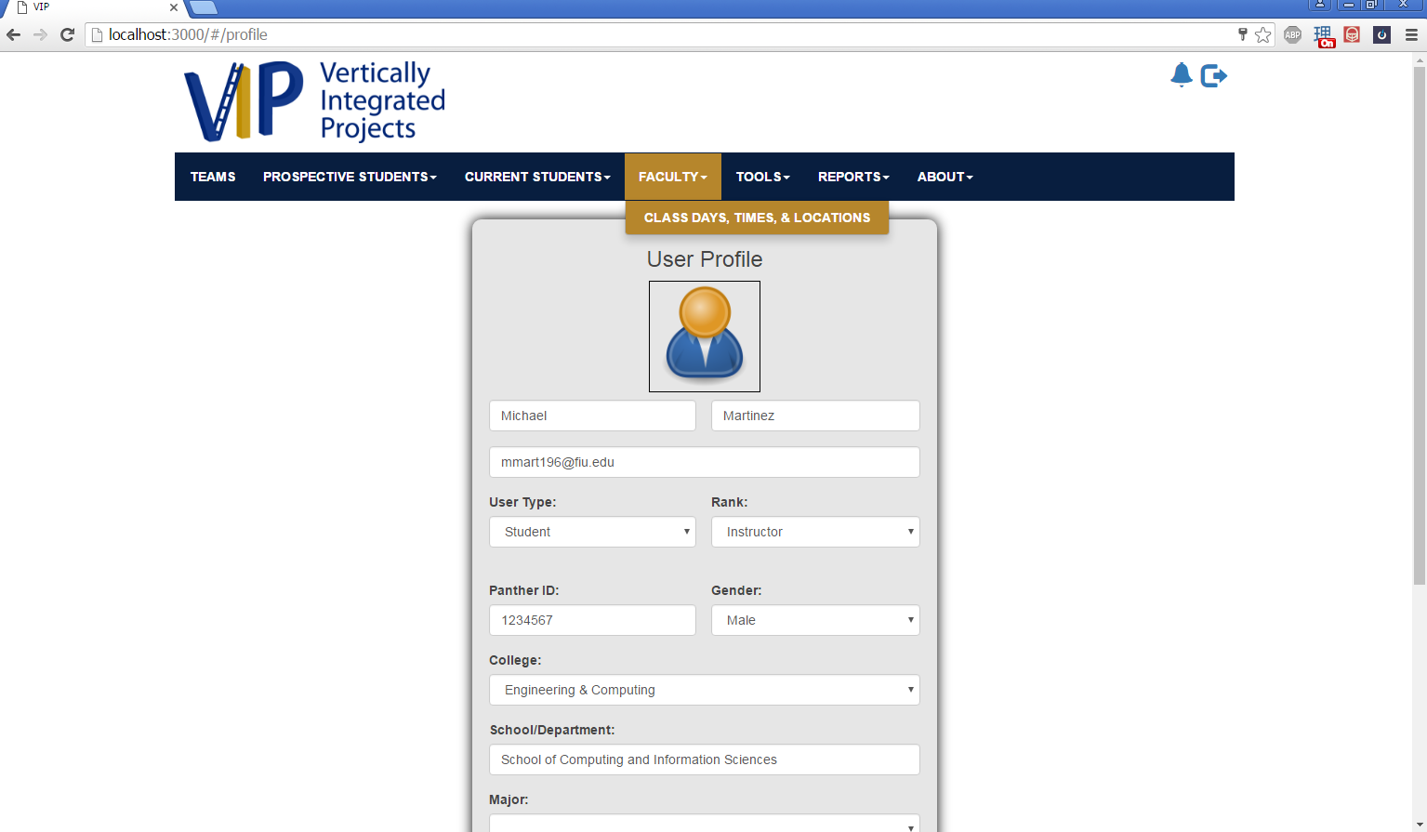

*Figure 2. Viewing FACULTY As a* ***Staff/Faculty***

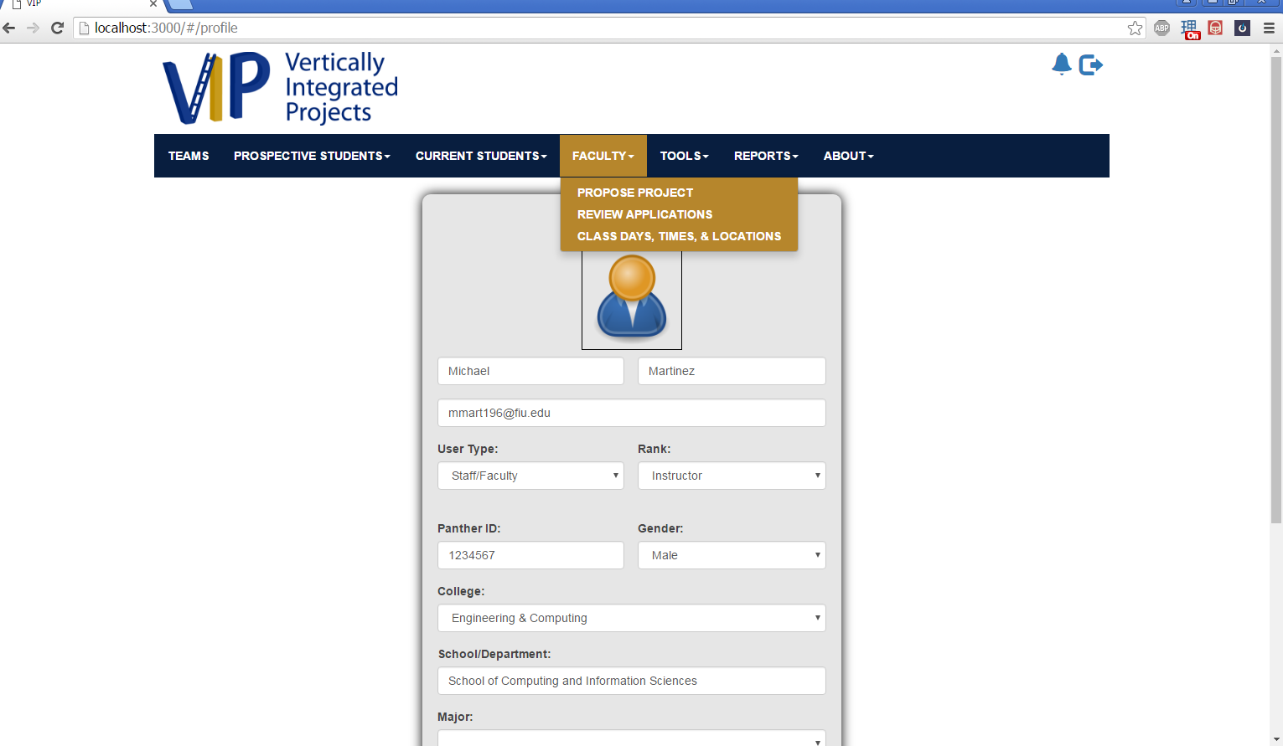

*Figure 3. Viewing PROSPECTIVE STUDENTS As a* ***Staff/Faculty***

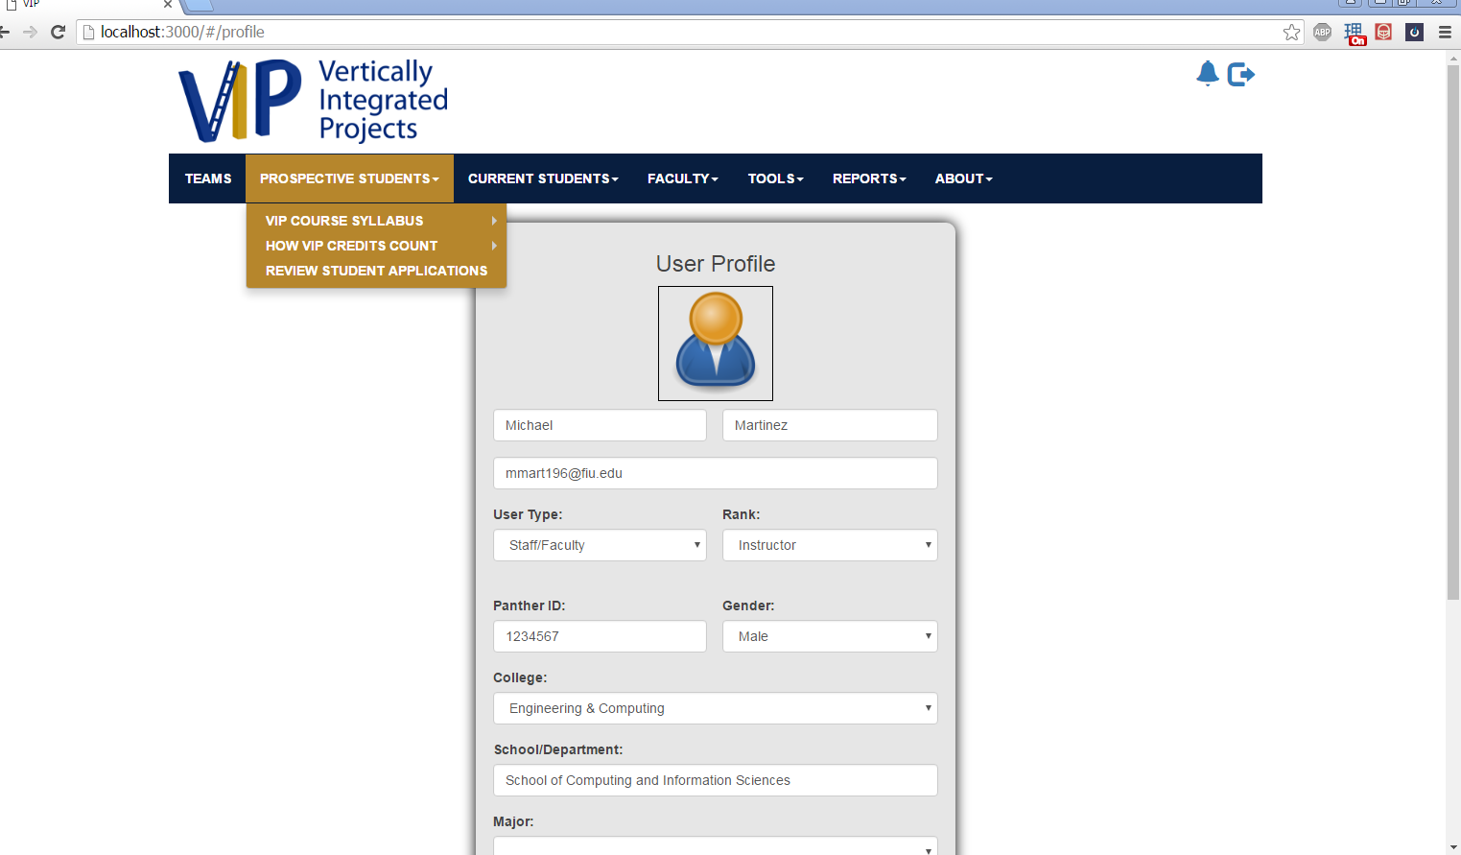

*Figure 4. Viewing FACULTY As a* ***PI/CO-PI***

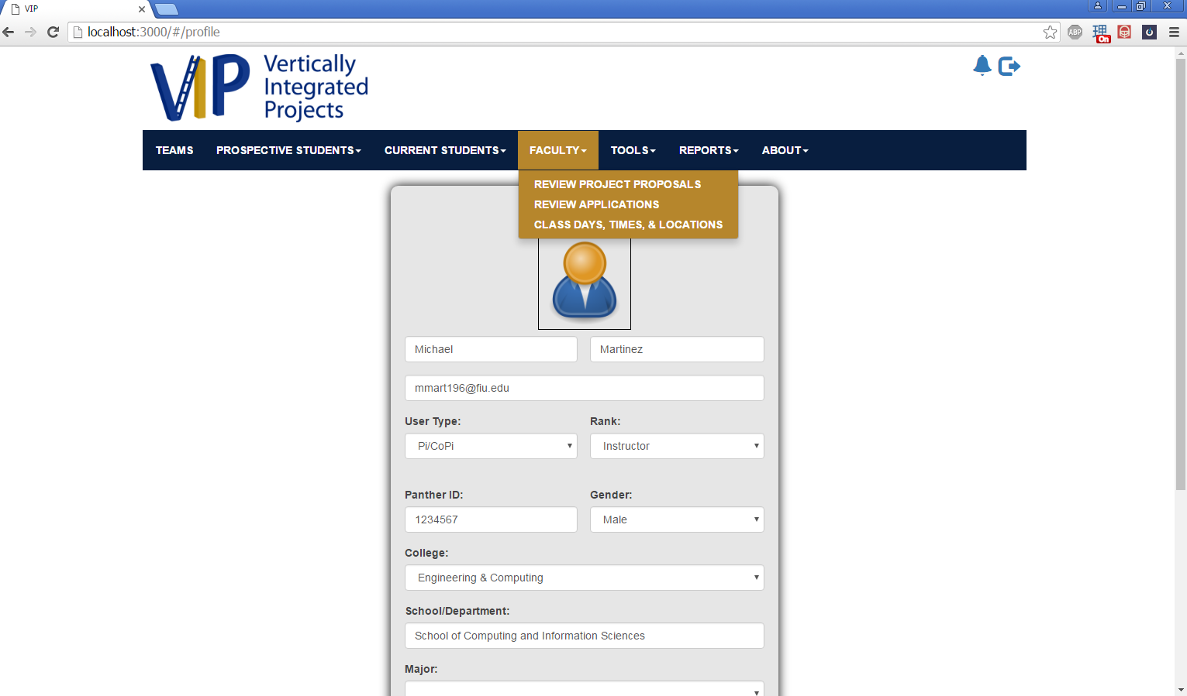

*Figure 5. Viewing PROSPECTIVE STUDENTS As a* ***PI/CO-PI***

